Working Group 2

|  |  |  |  |  |  |  |  |  |  |  |
| --- | --- | --- | --- | --- | --- | --- | --- | --- | --- | --- |
| Author : | | Christian GIRAUD | | Date : | 28/10/2013 | | | | | |
|  | | | | | | | | | | |
| **Subject :** | | | | | | | Document Review : | | 🗹 | |
| **OpenETCS WP3 Task Force** | | | | | | | Design Review : | | ❒ | |
| WG 2 Track_Condition - provisional - | | | | | | | Other : | |  | |
|  | |  | | | | | | | | |
|  |  | |  | | |  | |  | |  |
|  |  | |  | | |  | |  | |  |

|  |  |  |
| --- | --- | --- |
| **Name** | **Position** | **Company / Department** |
| Valerio Raimondi |  | Alstom |
| Stephane Besure |  | Alstom |
| Nicolas Boverie |  | Alstom |
| Christian Giraud |  | Alstom |
| Yoann Guyot |  | Cetic |
| Baseliyos Jacob |  | DB |
| Bernd Hekele |  | DB |
| Niklas Schaffrath |  | Siemens |
| Uwe Steinke |  | Siemens |
| Jos Holtzer (present on 22/10) |  | NS |
| Jan Welvaarts |  | L’loyds Register Rail |
| Sylvain Baro |  | SNCF |
| Marielle Petit-Doche |  | Systerel |
| Jan Welte (present from 23/10) |  | TU Braunschweig |
|  |  |  |
|  |  |  |

**Distribution to:**

|  |  |  |
| --- | --- | --- |
| **Name** | **Position** | **Company / Department** |
| Pierre-François Jauquet |  | Alstom TIS |
|  |  |  |
|  |  |  |
|  |  |  |
|  |  |  |
|  |  |  |
|  |  |  |
|  |  |  |
|  |  |  |
|  |  |  |
|  |  |  |
|  |  |  |

Table of Content

1. Track condition 3

1.1 references 3

1.2 object 3

1.3 description 4

1.3.1 General 4

1.3.2 Initialization 4

1.3.3 Non Linear Anticipation 5

1.3.4 Architecture Diagrams 7

1.3.5 Points of Anticipation 9

1.4 Track Condition Function 11

1.4.1 Powerless Track Condition 11

1.4.2 Air Tightness Track Condition 13

1.4.3 Sound Horn Track Condition 13

1.4.4 Radio Hole Track Condition 14

1.4.5 No Stopping Area Track Condition 15

1.4.6 Tunnel Stopping Area Track Condition 16

1.4.7 Change of Traction Track Condition 17

1.4.8 Change of Allowed Current Consumption Track Condition 17

1.4.9 Big Metal Mass Track Condition 17

1.4.10 Switch off Various Regenerative Brake Track Condition 17

1.4.11 Station Platform Track Condition 18

1.5 Big Metal Mass Data packet n°67 19

1.6 Standard Data packet n°68 21

1.7 Platform Data packet n°69 24

# Track condition

## references

UNISIG Subset_026 version_3.3.0

Chapter 3 : ERTMS / ETCS Principes

Chapter 5 : ERTMS / ETCS Procedures

Chapter 7 : ERTMS / ETCS Language

## object

[SRS-026-chapter : 3.12.13]

Track Conditions objective is to provide to driver and/or to train, some information in front of the train.

These conditions are related to:

1. Powerless section with pantograph to be lowered, potentially including a change of traction system,
2. Powerless section with main power switch to be switched off,
3. Non-stopping area,
4. Radio hole,
5. Air tightness area,
6. Inhibition of a defined type of brake in power recovery,
   1. switch off regenerative Brake,
   2. switch off eddy current in Service Brake,
   3. switch off eddy current in Emergency Brake,
   4. switch off magnetic shoes Brake,
7. Tunnel stopping area,
8. Sound horn,
9. Big Metal Mass,
10. Station Platform definition,
11. Change of traction system,
12. Change of allowed current consumption.

## description

[SRS-026-chapter : 3.12.1]

### General

Each Track Condition is given as a Profile Data, i.e. start and end of the data is given or simply location data, depending on the type of track condition.

The starting position is in reference to the “Max Safe Front End” position of the train.

The end position is in reference to the “Min Safe Rear End” position of the train.

The timing is dealt as a specific application.

There are some exceptions about these rules:

* exception 1 : The starting point of a Big Metal Mass type track condition shall be evaluated taking into account the max safe antenna position, the end of the profile taking into account the min safe antenna position.
* exception 2 : The end of the Powerless section shall be evaluated taking into account the min safe front end of the train.
* exception 3 : The start and end of a tunnel stopping area and of a sound horn track condition shall be evaluated taking into account the estimated front end of the train.

Note :

* In case of regenerative or magnetic brake switch off, the Emergency Brake Deceleration might be affected if taken into account in value estimation.
* In case of SB or EB, the eddy current brake might be also affected.
* In case of powerless section, EB or SB deceleration might be affected by presence of voltage in catenary.

### Initialization

[SRS-026-chapter : 3.12.1.3]

When receiving one track condition, the following actions shall be performed :

* Indicate on DMI the necessary actions described within chapter 3.12 of subset-026,
* Send to external equipment the remaining distance when necessary.

The functions covered by the “Track Condition” packets number 39, 40, 67, 68 and 69 are described within the chapters hereafter.

An abstract list is given hereafter.

| **Coding** | **Type Definition** | **Initial States** | **Active States** | **Anticipation** |
| --- | --- | --- | --- | --- |
| 0000 | No Stopping Area | Stopping permitted | No Stopping permitted within area | Use SBI curve |
| 0001 | Tunnel Stopping Area | No Stopping | Stopping permitted within area | Use SBI curve |
| 0010 | Sound Horn Area | No Sound requested | Sound requested | DAN = V * TAN |
| 0011 | Powerless Section – lower Pantograph | No power | Power | DAN = V * TAN |
| 0100 | Radio Hole | T_NVContact supervised | T_NVContact not supervised | DAN = 0 |
| 0101 | Air Tightness | No Air-Tightness requested | Air-Tightness requested | DAN = V * TAN |
| 0110 | Switch off regenerative brake | Regenerative brake on | Regenerative brake off | DAN = V * TAN |
| 0111 | Switch off eddy current SB | Eddy current SB on | Eddy current SB off | DAN = V * TAN |
| 1000 | Switch off magnetic shoes | Magnetic Shoes on | Magnetic Shoes off | DAN = V * TAN |
| 1001 | Powerless Section – Power Main Switch | Main Power on | Main Power off | DAN = V * TAN |
| 1010 | Switch off eddy current EB | Eddy current EB on | Eddy current EB off | DAN = V * TAN |
| Packet 67 | Big Metal Mass, | No integrity check ignore | Integrity check ignore | DAN = 0 |
| Packet 69 | Station Platform definition | No target in station | Target in station | Use SBI curve |
| Packet 39 | Change of traction system? Is coupled with “Powerless & Lowering pantograph ? | No change of traction system | Change of traction system | DAN = V * TAN |
| Packet 40 | Change of allowed current consumption | No change of allowed current | Change of allowed current | DAN = V * TAN |

Note :

* + - SBI curve : gives a DAN = distance of anticipation = function(V)
    - DREM = distance of remain,
    - TAN = time of anticipation
    - V = actual train speed

### Non Linear Anticipation

[SRS-026-chapter : 3.4]

The issue is to define the SBI curve (curve of Service Brake Intervention) which permits :

* to stop the train before the beginning of an area
* and after the end of area, starting from an initial speed so-called “Vest” (V estimated)
* and following 2 assumptions ::
  + Deceleration is a constant value
  + Deceleration is variable due to gradients or other factors.

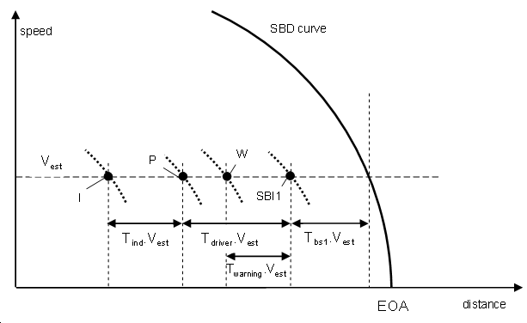

We take in consideration the limit of area as an EOA.

* SBD constant :
  + The distance to decrease speed from “Vest” to zero with constant deceleration Gsb is :

**Dsb = Vest ² / (2 * Gsb**) equation of “SBD curve”

* + Taking in consideration all response times, the distance will be :

**Dind = [ Vest ² / (2 * Gsb)] + [ Vest * (Tbs1 + Tdriver + Tind)]** equation of “Indication curve”

* SBD variable step by step :
  + The distance due to response times is unchanged :

**Dres = [ Vest * (Tbs1 + Tdriver + Tind)]** equation of “response time”

* + The distance due to 1st step defined by {V1 and Gsb1} is :

**Dind1 = [ V1 ² / (2 * G1)]**

* + The distance due to 2ndt step defined by {V2 and Gsb2} is :

**Dind2 = [ (V2 ² - V1 ²) / (2 * G2)]**

* + The distance due to step “n” defined by {Vn and Gsbn} is :

**Dend = [ (Vest ² - Vn ²) / (2 * Gn)]**

* + The final distance due to step “n =3” is the sum up :

**Dind = Dind1 + Dind2 + Dend**

Note :

* the last step includes the estimated speed,
* the final distance of anticipation includes all response time,
* this distance could be limited to “intervention” or “warning.

### Architecture Diagrams

[SRS-026-chapter : 3.4]

See SysML diagrams (BDD, IBD, STM),

Provisionally, a SADT diagram is described hereafter.

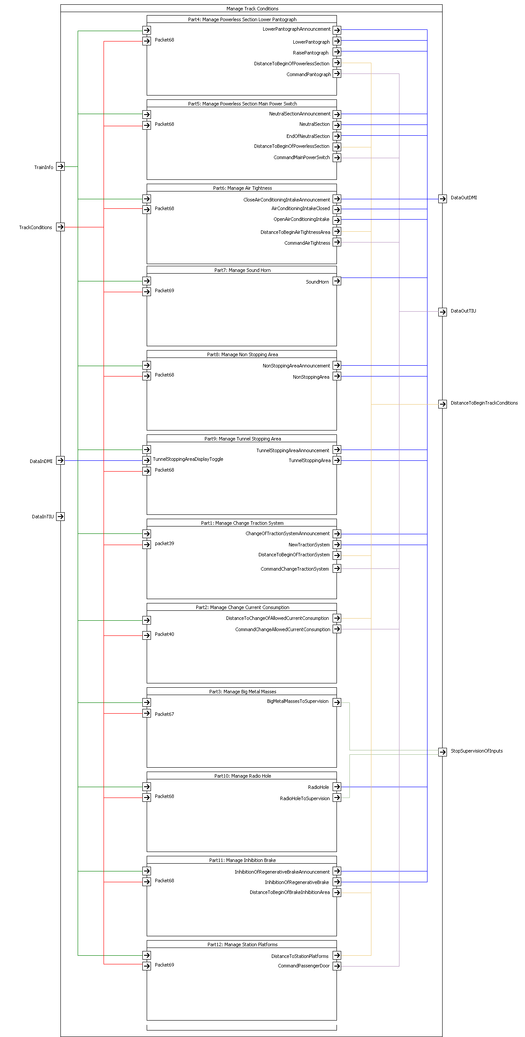

**Figure 1: Track Condition Datagram**

Database architecture:

The architecture is based on a set of classified data blocks,

One block is used each time an input parameter changes of value or status,

The blocks are classified by a double uplink and downlink,

That permit to scan the block from train position to EOA and conversely.

At any moment, it is possible to insert or to withdraw a block in the chain (or link).

We define a double link :

* One link in the direction of travel, that permits to expore the capacity to respect EOA,
* One link in the opposite direction, that permits to compute a maximum speed curve which respect the EOA .

Hereafter are listed all type of data involved in ETCS On-board :

* Balise Linking
* Static Speed Profile
* Axle Load Speed Restriction
* Signalling Related Speed Restriction
* Mode Related Speed Restriction
* Temporary Speed Restriction
* Gradiants
* Track Condition
* Route Suitability
* Radio Mapping

### Points of Anticipation

[SRS-026-chapter : 3.18.1 & 2]

Each “Track Condition” is associated to several singular points named “A”, “B”, etc.. up to “F” whose definition and location are given hereafter.

* + Point ”A” : this is the location of the transponder balise or the “LRBG” if data are coming by radio,
  + Point “B” : ???
  + Point ”C” : this is the location where the track condition function is announced on the DMI to the driver, taking into account the max safe front end of the train,
  + Point “D” : this is the location where the track condition function is active and displayed on the DMI to the driver,
  + Point “E” : this is the location where the track condition function is de-active and displayed on the DMI to the driver,
  + Point “F” : this is an intermediate location at mid distance between D & E (for “Change of traction system”) and at mid distance between E & F (for “Non stopping area”),
  + Point “G” : this is the terminal location where the track condition function and DMI display are both over, taking into account the min safe rear end of the train.

D_TRACKCOND

D_TRACKCOND(1)

L_TRACKCOND

L_TRACKCOND(1)

**Direction Of Runing**

**Reference position**

**(balise transmiting or LRBG)**

**A**

**C**

**G**

**D**

**E**

**D1**

**E1**

DREM

DAN

**Figure 2 : Position of singular points**

The drawing hereunder shows :

* One balise group at position A transmitting one Track Condition packet n°67 which includes two”Track Condition” changes :
  + First change at position “D”,
  + Second change at position D1
* N_ITER is equal to 1..

## Track Condition Function

[SRS-026-chapter : 3.12]

### Powerless Track Condition

[SRS-026-chapter : 5.18.2 & 3]

There are two type of “Powerless Section” :

* The “Powerless / Lower Pantograph” is a singular Track Condition function which is managed by the mean of packet number 68 with internal code 3 (M_TRACKCOND=3).
  + This function is active (no power / low pantograph) when the Max Safe Front End overpasses the declared position where “Track Condition” changes (i.e. D_TRACKCOND of packet n°68).
  + This function is de-active ( power / high pantograph) when the Min Safe Front End overpasses the declared position where “Track Condition” resumes (i.e. D_TRACKCOND + L_TRACKCOND of packet n°68).
  + This function is announced on DMI when the Max Safe Front End overpasses the calculated position of “Point C” in rear of the beginning of the powerless section (Point D).
  + The initial state is function resume or de-active.
  + The status of function is displayed from C to G.
* The “Power Main Switch” is a singular Track Condition function which is managed by the mean of packet number 68 with internal code 9 (M_TRACKCOND=9).
  + This function is active (main power switch off) when the Max Safe Front End overpasses the declared position where “Track Condition” changes ( i.e. D_TRACKCOND of packet n°68).
  + This function is de-active (main power switch on) when the Min Safe Front End overpasses the declared position where “Track Condition” resumes ( i.e. D_TRACKCOND + L_TRACKCOND of packet n°68).
  + This function is also announced on DMI when the Max Safe Front End overpasses the calculated position of “Point C” in rear of the beginning of the powerless section (Point D).
  + The initial state is function resume or de-active.
  + The status of function is displayed from C to G.
* The two types of “Powerless Section” are managed on the same manner, but :
  + The 1st one is ordering the pantograph, manually or automatically, with interaction with the function “Change of Traction”
  + The 2nd one is ordering the Main Power Switch, manually or automatically, alone.
* Following Train Configuration, both technics can be involved.
* The ”Change of Traction” system seems to be programmable as an option.

Hereafter is a drawing of a powerless section with a pantograph to be lowered.

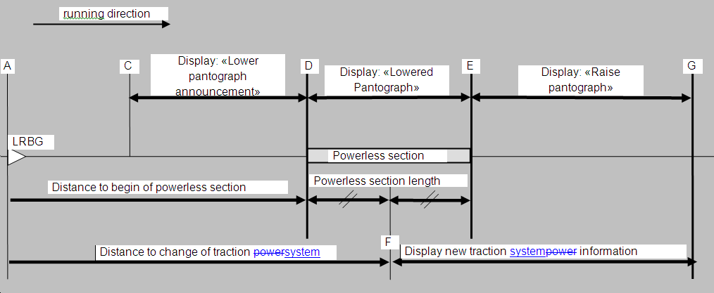

**Figure 3: Powerless section with pantograph lower**

Hereafter is a drawing of a powerless section with **main power switch to be switched off**

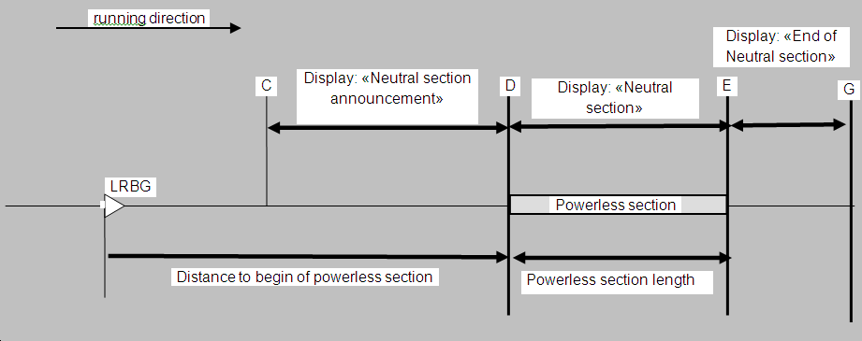

**Figure 4: Powerless section with main power switch to be switched off**

### Air Tightness Track Condition

[SRS-026-chapter : 5.18.6]

The “Air Tightness” is a regular Track Condition function which is managed by the mean of packet number 68 with internal code 5 (M_TRACKCOND=5).

* This function is active ( air tightness request ) when the Max Safe Front End overpasses the declared position where “Track Condition” changes ( i.e. D_TRACKCOND of packet n°68).
* This function is de-active ( power / high pantograph) when the Min Safe Rear End overpasses the declared position where “Track Condition” resumes ( i.e. D_TRACKCOND + L_TRACKCOND of packet n°68).
* The initial state is function resume or de-active.
* The next drawing shows the phase “A” up to “G” :

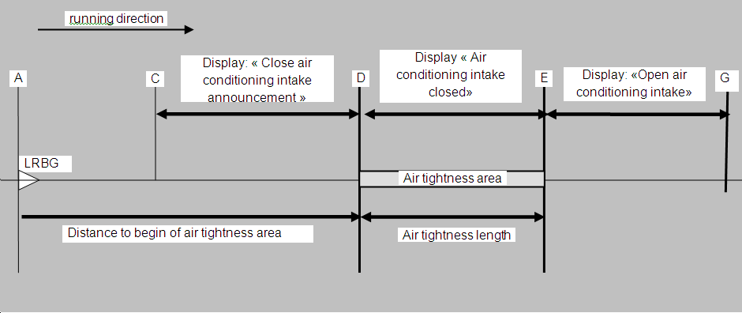

**Figure 5: Passing an air tightness area**

The packet n°68 gives position of points A, D & E.

Points C & G are calculated with train parameters.

### Sound Horn Track Condition

[SRS-026-chapter : 5.18.9]

The “Sound Horn” is a singular Track Condition function which is managed by the mean of packet number 68 with internal code 2 (M_TRACKCOND=2).

* This function is active ( sound horn request ) when the Estimate Front End overpasses the declared position where “Track Condition” changes ( i.e. D_TRACKCOND - DAN of packet n°68).
* This function is de-active (sound horn not request) when the Estimate Front End overpasses the declared position where “Track Condition” changes ( i.e. D_TRACKCOND + L_TRACKCOND of packet n°68).
* The initial state is function resume or de-active.

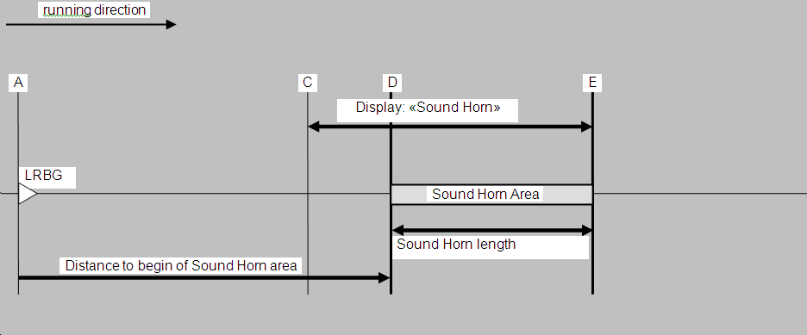

**Figure 6: Passing an air tightness area**

The packet n°68 gives position of points A, D & E.

Points C is calculated with train parameters.

### Radio Hole Track Condition

[SRS-026-chapter : 5.18.5]

The “Radio Hole” is a regular Track Condition function which is managed by the mean of packet number 68 with internal code 4 (M_TRACKCOND=4).

* This function is active ( “T_NVCONTACT “ not supervised ) when the Max Safe Front End overpasses the declared position where “Track Condition” changes ( i.e. D_TRACKCOND of packet n°68).
* This function is de-active ( “T_NVCONTACT “ supervised ) when the Min Safe Rear End overpasses the declared position where “Track Condition” resumes ( i.e. D_TRACKCOND + L_TRACKCOND of packet n°68).
* The initial state is function resume or de-active.

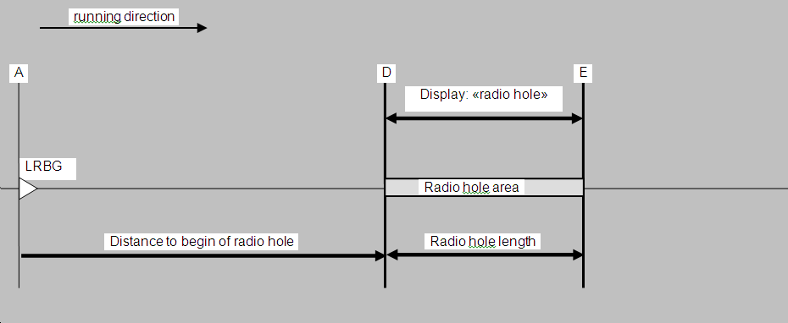

**Figure 7: Passing a radio hole area**

The packet n°68 gives position of points A, D & E.

### No Stopping Area Track Condition

[SRS-026-chapter : 5.18.4]

This function is used to announce and indicate to the driver the presence of an area where stopping is not permitted. This function takes into account the SBI curves and estimated train speed.

The “no stopping area” is a regular Track Condition function which is managed by the mean of packet number 68 with internal code 0 (M_TRACKCOND=0).

* This function is active ( no stopping permitted ) when the Max Safe Front End overpasses the declared position where “Track Condition” changes ( i.e. D_TRACKCOND of packet n°68 – Distance_To_Stop_SBID).
* This function is de-active ( stopping permitted) when the Min Safe Front End overpasses the declared position where “Track Condition” resumes ( i.e. D_TRACKCOND + L_TRACKCOND of packet n°68 + Train_Length - Distance_To_Stop_SBIG).
* The initial state is function resume or de-active (stop permitted).
* There are two ‘Distance_To_Stop” to be calculated, taking into account the “Estimated Train Speed” :
  + Distance_To_Stop_SBID is based on “service brake intervention” curve related to stop at location “D”.
  + Distance_To_Stop_SBIG is based on “service brake intervention” curve related to stop at location “G”.
  + With these two curves, two conclusions are possible :
    - Below SBID and Over SBIG : no display.
    - Between SBID and SBIG : display non stopping area with ”announcement” before ”D” location.

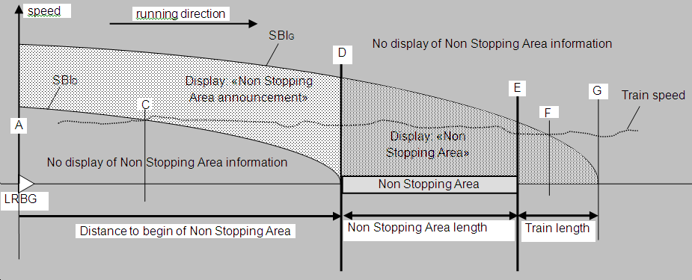

**Figure 8: Passing a non stopping area**

### Tunnel Stopping Area Track Condition

[SRS-026-chapter : 5.18.8]

The “Tunnel Stopping Area” is a singular Track Condition function which is managed by the mean of packet number 68 with internal code 1 (M_TRACKCOND=1).

The on-board has to check the current speed and position to define if the train can be stopped before the”E” point, considering a stop before ”D” can be avoided.

* This function is active ( stopping permitted ) when the Max Safe Front End does not overpass the declared position where “Track Condition” changes ( i.e. D_TRACKCOND + L_TRACKCOND of packet n°68 – Distance_To_Stop_SBIE).
* This function is de-active ( no stopping permitted ) when the Max Safe Front End overpasses the declared position where “Track Condition” resumes ( i.e. D_TRACKCOND + L_TRACKCOND of packet n°68 – Distance_To_Stop_SBIE).
* The initial state is function resume or no stopping permitted.
* There are one ‘Distance_To_Stop” to be calculated, taking into account the “Estimated Train Speed” :
  + Distance_To_Stop_SBIE is based on “service brake intervention” curve related to stop at location “E”.
  + Two conclusions are possible :
    - Below SBIE : display “Tunnel Stopping Area” with announcement before “D” location.
    - Over SBIE : no display.

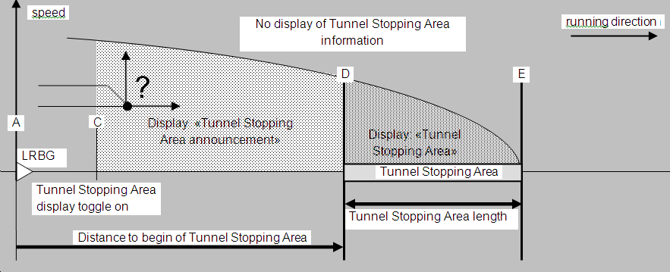

**Figure 9: Passing a Tunnel stopping area**

### Change of Traction Track Condition

The “Change of Traction” is a singular Track Condition function which is managed by the mean of packet number 39.

* This function is active ( traction change ) when the Max Safe Front End overpasses the declared position where “Track Condition” changes ( i.e. D_TRACKCOND of packet n°68).
* This function is never de-active.
* There should be one selection per voltage.

TBD more

### Change of Allowed Current Consumption Track Condition

TBD more, packet 40.

### Big Metal Mass Track Condition

[SRS-026-chapter : 5.18.x]

The “Big Metal Masses” is a singular Track Condition function which is managed by the mean of packet number 67.

* This function is active ( integrity check alarm ignore ) when the Max Safe Antenna position overpasses the declared position where “Track Condition” changes ( i.e. D_TRACKCOND of packet n°67).
* This function is de-active ( alarm not ignore ) when the Min Safe Antenna overpasses the declared position where “Track Condition” resumes ( i.e. D_TRACKCOND + L_TRACKCOND of packet n°67).
* The initial state is function resume or alarm not ignore.

### Switch off Various Regenerative Brake Track Condition

[SRS-026-chapter : 5.18.7]

There are 4 functions of switching off the regenerative brake.

All of them are a regular Track Condition function which is managed by the mean of packet number 68 with internal code 6, 7, 8, 10 (M_TRACKCOND=6, 7, 8, 10).

* This function is active ( switch switched off ) when the Max Safe Front End overpasses the declared position where “Track Condition” changes ( i.e. D_TRACKCOND of packet n°68).
* This function is de-active (switch switched on ) when the Min Safe Rear End overpasses the declared position where “Track Condition” resumes ( i.e. D_TRACKCOND + L_TRACKCOND of packet n°68).
* The initial state is function resume or de-active.

The 4 “Switch off” functions are :

* Switch off Regenerative Brake (code 6)
* Switch off Eddy for service brake (code 7)
* Switch off Eddy for magnetic shoes (code 8)
* Switch off Eddy for emergency brake (code 10).

### Station Platform Track Condition

[SRS-026-chapter : 5.18.x]

The “Station Platform Track Condition” is a singular Track Condition function which is managed by the mean of packet number 69.

This function is active ( a stopping point is target ) when the Max Safe Front End position overpasses a balise which provide a data packet number 69 containing a set of stopping points.

In accordance with the journey, a target is defined with the declared position where “Track Condition” changes ( i.e. D_TRACKCOND of packet n°69).

This function is de-active ( no target ) when the Min Safe Rear End overpasses the declared position or stop.

The content of packet 69 is repeated by 2 or more balises located some hundred meters before the stopping point, whose objective is to improve the positioning accuracy, if necessary.

This improvement is mandatory in case of PSD (Platform Screen Doors). In this case, an accuracy of 10 cm with a probability of 10exp-4 is expected.

Note : in case of PSD, a vital order coming from on-board needs to be transmitted to station in order to grant that train is stopped at the right location. For this reason, we envision the use of ”Stopping Point Identifier” to satisfy the safety of PSD system.

Note : this ”Stopping Point Identifier” is described in red on the next drawing.

## Big Metal Mass Data packet n°67

[SRS-026-chapter : 3.12.1 & 7.4.2.19]

The packet number 67 describes the profile of “Big Metal Mass” data related to current MA..

The details are given in the table and within the figure hereafter.

This packet is transmitted by one balise group, the location of which is the reference for data.

|  |  |  |  |
| --- | --- | --- | --- |
| ***Description*** | The packet gives details concerning where to ignore integrity check alarms of balise transmission due to big metal masses trackside. | | |
| ***Medias*** | Balise | | |
| ***Content*** | **Variable** | Length | **Comment** |
|  | NID_PACKET | 8 | Is equal to 67 |
|  | Q_DIR | 2 | Validity direction :  a : ref. balise group (media balise)  b : ref. LRBG (media radio) not applicable  00 : reverse direction  01 : nominal direction  10 : both direction  11 : spare |
|  | L_PACKET | 13 | Size of the packet in number of bits,  Starting from beginning of packet |
|  | Q_SCALE | 2 | Scale for « D » and « L » data  00 : quantum 10 cm  01 : quantum 1 m  10 : quantum 10 m  11 : spare |
|  | D_TRACKCOND | 15 | Distance from “Reference” position to beginning of “integrity check” is inhibited |
|  | L_TRACKCOND | 15 | Length for which integrity check alarms of balise transmission shall be ignored |
|  | N_ITER | 5 | Number of iteration. If equal 0, end of the packet. |
|  | D_TRACKCOND(k) | 15 | Iteration of : Incremental distance from previous” position to beginning of “integrity check” is inhibited |
|  | L_TRACKCOND(k) | 15 | Iteration of : Iterative length for which integrity check alarms of balise transmission shall be ignored |

**Figure 10: Description of Packet n° 67**

The drawing shows several location where integrity check is inhibited within a sole message.

D_TRACKCOND

D_TRACKCOND(1)

L_TRACKCOND

L_TRACKCOND(1)

**Direction Of Travel**

**Reference position**

**(balise transmiting)**

**Figure 11: Drawing related to Packet n° 67**

Note :

* In this example, there is only one iteration.
* The first inhibition is terminated when the second inhibition starts.
* We could have an interleaving of several “L-TRACKCOND”.
* The result gives a “Profile” of “TRACKCOND.

Question:

* What happen on reception of new LRBG ?
  + All old track conditions are reset ?
  + Old track conditions continue with the new reference ?
* D_TRACKCOND and D_TRACKCOND(1) are they incremental ?

## Standard Data packet n°68

[SRS-026-chapter : 7.4.2.20]

The packet number 68 describes details concerning the track ahead to support the driver when e.g. lower pantograph

Only one “Track Condition” changes at a time.

The details are given in the table and within the figure hereafter.

| ***Description*** | The packet gives details concerning where the track condition change ahead of the train | | |
| --- | --- | --- | --- |
| ***Medias*** | Any | | |
| ***Content*** | **Variable** | Length | **Comment** |
|  | NID_PACKET | 8 | Is equal to 68 |
|  | Q_DIR | 2 | Validity direction :  a : ref. balise group (media balise)  b : ref. LRBG (media radio)  00 : reverse direction  01 : nominal direction  10 : both direction  11 : spare |
|  | L_PACKET | 13 | Size of the packet in number of bits,  Starting from beginning of packet |
|  | Q_SCALE | 2 | Scale for « D » and « L » data  00 : quantum 10 cm  01 : quantum 1 m  10 : quantum 10 m  11 : spare |
|  | Q_TRACKINIT | 1 | If = 0 profile empty,  resume initial states – see associated table |
|  | D_TRACKINIT | 15 | If Q_TRACKINIT = 0  Distance from ”reference” position where initial states of the related track description in the packet shall be resumed,  With quantum = 10 cm 🡪 32767 * 10 /100  D_TRACKINIT = [0…3276 m]  End of packet |
|  | D_TRACKCOND | 15 | If Q_TRACKINIT = 1  Distance from “reference” position to where the track conditions change |
|  | L_TRACKCOND | 15 | Length for which the defined track condition is valid |
|  | M_TRACKCOND | 15 | One value per Track Condition :  0000 : no stopping area  0001 : tunnel stopping area  0010 : sound horn  0011 : powerless section - lower pantograph  0100 : radio hole  0101 : air tightness  0110 : Switch off regenerative brake  0111: Switch off eddy current brake for service brake  1000 : Switch off magnetic shoe brake  1001 : Powerless section – switch off the main power switch  1010 : Switch off eddy current brake for emergency brake  1010 to 1111 : spare |
|  | N_ITER | 5 | Number of iteration. If equal 0, end of the packet. |
|  | D_TRACKCOND(k) | 15 | Iteration of Incremental distance to where the track conditions change |
|  | L_TRACKCOND(k) | 15 | Iteration of Length for which the defined track condition is valid |
|  | M_TRACKCOND(k) | 15 | Iteration of Track Condition |

**Figure 12: Description of Packet n° 68**

Initial values when resume are given within table hereafter.

|  |  |  |
| --- | --- | --- |
| **Coding** | **Type Definition** | **Initial States** |
| 0000 | No Stopping Area | Stopping permitted |
| 0001 | Tunnel Stopping Area | No Stopping |
| 0010 | Sound Horn | No Sound requested |
| 0011 | Powerless Section – lower P. | No power |
| 0100 | Radio Hole | T_NVContact supervised |
| 0101 | Air Tightness | NoAirTightness requested |
| 0110 | Switch off regenerative brake | Regenerative brake on |
| 0111 | Switch off eddy current SB | Eddy current SB on |
| 1000 | Switch off magnetic shoes | Magnetic Shoes on |
| 1001 | Switch off Main Power | Main Power on |
| 1010 | Switch off eddy current EB | Eddy current EB on |

**Figure 13: Description of Packet n° 68, initial values**

The drawing shows several location where Track Condition is changing within a sole message including a “radio hole” and a “powerless section”.

D_TRACKCOND

D_TRACKCOND(1)

L_TRACKCOND = Length of radio hole

L_TRACKCOND(1) =

Length of powerless)

**Direction Of Travel**

**Reference position**

**( balise transmitting**

**or LRBG if radio )**

M_TRACKCOND = 4

( radio hole )

M_TRACKCOND = 3

( powerless - lower pantograph )

D_TRACKCOND(2)

**Figure 14: Description of Packet n° 68, Drawing**

## Platform Data packet n°69

[SRS-026-chapter : 7.4.2.20.1]

The packet number 69 describes the profile of “Platform” data related to “Stopping Point” in station.

The details are given in the table and within the figure hereafter.

This packet is transmitted by one balise group (for announcement) and is repeated by several alone balises, depending on target accuracy we need.

The details are given in the table and within the figure hereafter.

|  |  |  |  |
| --- | --- | --- | --- |
| ***Description*** | The packet gives details concerning where to stop at a platform with a good accuracy enough efficient to permit a stop in station. | | |
| ***Medias*** | Balise | | |
| ***Content*** | **Variable** | Length | **Comment** |
|  | NID_PACKET | 8 | Is equal to 69 |
|  | Q_DIR | 2 | Validity direction :  a : ref. balise group (media balise)  b : ref. LRBG (media radio)  00 : reverse direction  01 : nominal direction  10 : both direction  11 : spare |
|  | L_PACKET | 13 | Size of the packet in number of bits,  Starting from beginning of packet |
|  | Q_SCALE | 2 | Scale for « D » and « L » data  00 : quantum 10 cm  01 : quantum 1 m  10 : quantum 10 m  11 : spare |
|  | Q_TRACKINIT | 1 | If = 0 profile empty, resume initial states |
|  | D_TRACKINIT | 15 | If (Q_TRACKINIT=0) distance to start with empty profile : **end of packet** |
|  | D_TRACKCOND | 15 | Distance from “Reference” position to 1st target ( or 1st stop location) in station |
|  | L_TRACKCOND | 15 | Length after stop |
|  | M_PLATFORM | 4 | Height of platform related to 1st stop ( 16 values) |
|  | Q_PLATFORM | 2 | Qualifier of platform related to 1st stop :  00 : left side to open passengers doors  01 : right side  10 : both side  11 : spare |
|  |  |  |  |
|  | N_ITER | 5 | Number of iteration is number of stopping point on the same track / same station  If = 0 **end of packet** |
|  | D_TRACKCOND(k) | 15 | Distance from “Reference” position to kiem target ( or kiem stop location) in station |
|  | L_TRACKCOND(k) | 15 | Length after stop |
|  | M_PLATFORM(k) | 4 | Height of platform related to kiem stop |
|  | Q_PLATFORM(k) | 2 | Qualifier of platform related to kiem stop |

**Figure 15: Description of Packet n° 69**

D_TRACKCOND

D_TRACKCOND(1)

L_TRACKCONDl

2nd Repeat Balise

**Direction Of Travel**

**Reference position**

**( balise transmitting**

**or LRBG if radio )**

1st Target in station

1st Repeat Balise

2nd Target in station

**Figure 16: Description of Packet n° 69, Drawing**